**1. What is DAM and Why Do We Use It?**

**DAM** stands for **Digital Asset Manager**.

* It's a core feature of AEM used to **store, manage, and deliver digital assets** such as images, videos, documents, and more.
* **Why we use it:**
  + Centralized asset management
  + Versioning support
  + Renditions for responsive images
  + Metadata tagging
  + Workflow support (like review/approval)

**2. Create Folder in DAM and Upload Images**

**Steps:**

1. **Login to AEM Author instance** (http://localhost:4502)
2. Go to **Assets → Files**
3. Click **Create → Folder**
   * Name: myTraining
4. Inside myTraining, create folders:

bash

CopyEdit

/content/dam/myTraining/us/en-us

1. Go into en-us and click **Upload** to add **2 images**.
2. Now, author a page:
   * Navigate to **Sites → Your site → Create Page**
   * Use a template like “WKND Site Template” or your custom one.
3. Drag **Image component** onto the page.
   * Click the image placeholder → Browse DAM → select uploaded images.
   * Repeat for both.

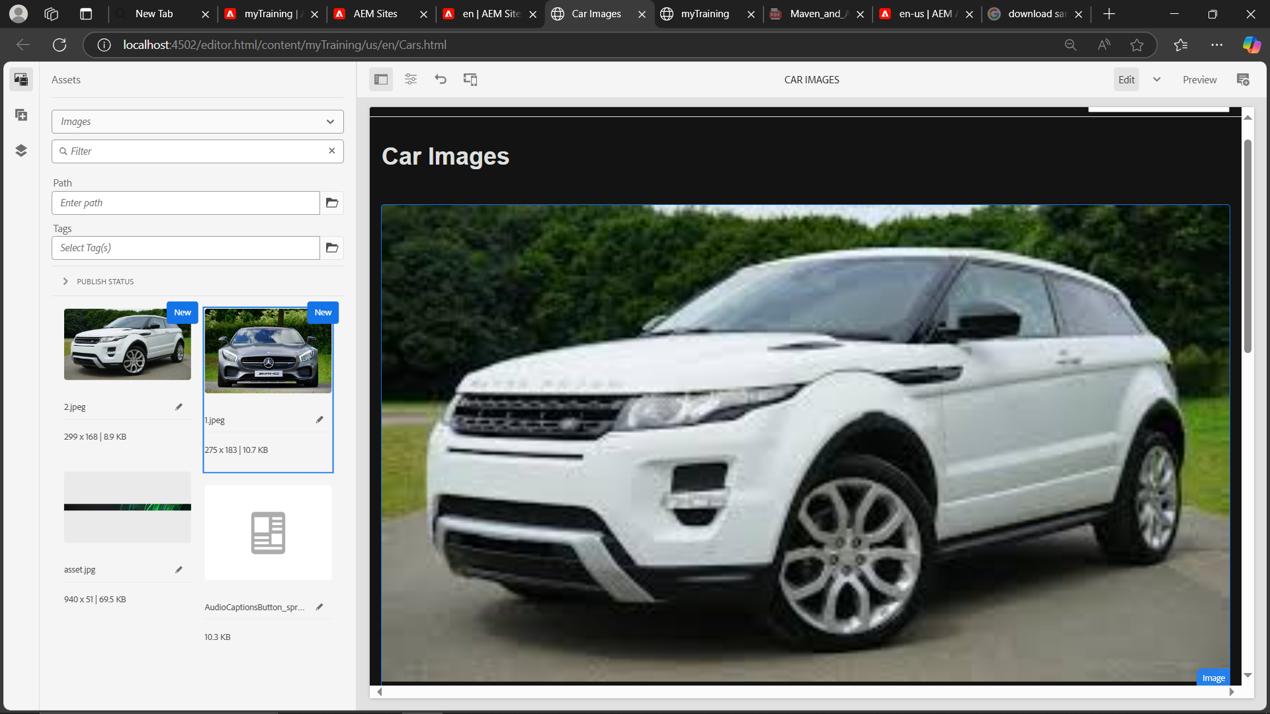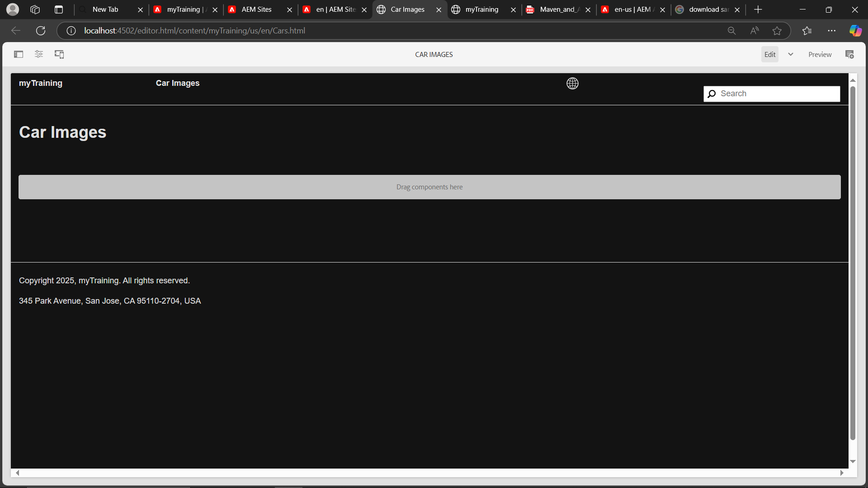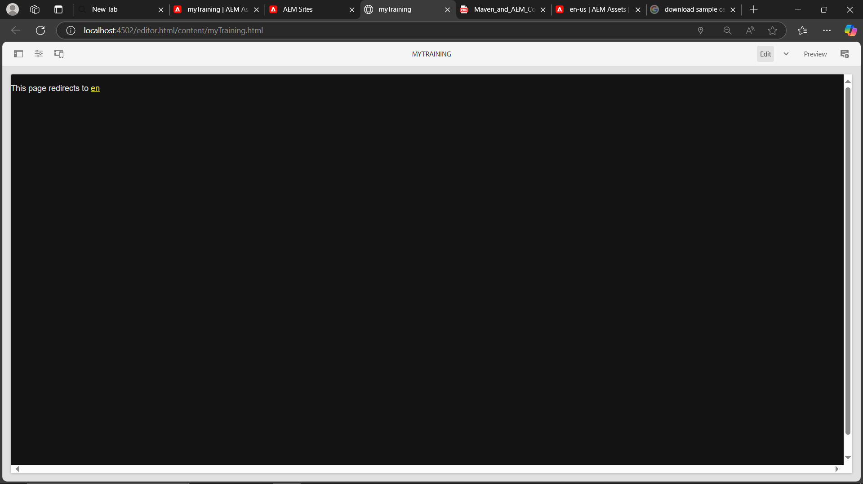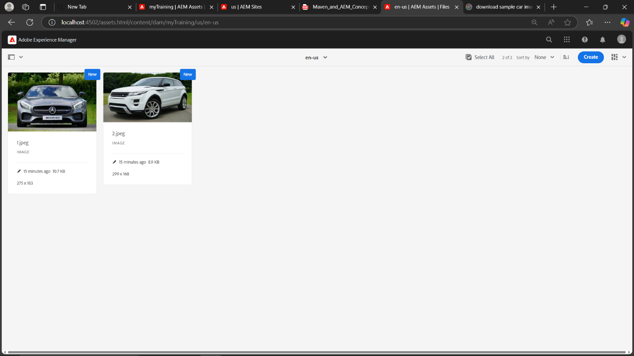

**3. What Are Renditions? How to View Them?**

**Renditions** are automatically or manually generated versions of an asset in different sizes or formats for use across devices.

**To check:**

1. Go to **Assets → Browse to your image**
2. Open the image → Click **Renditions tab**
3. You'll see renditions like:
   * cq5dam.thumbnail.48.48.png
   * cq5dam.web.1280.1280.png

These help optimize delivery across screens.

**4. Add FirstName and LastName to HelloWorld Component**

**Steps:**

1. Go to your **HelloWorld component folder** (e.g., /apps/myTraining/components/helloworld)
2. Edit helloworld.html and add:

html

CopyEdit

<p>First Name: ${properties.firstName}</p>

<p>Last Name: ${properties.lastName}</p>

1. Edit the **_cq_dialog/.content.xml** or TouchUI dialog:

xml

CopyEdit

<items jcr:primaryType="nt:unstructured">

<firstName

jcr:primaryType="nt:unstructured"

sling:resourceType="granite/ui/components/coral/foundation/form/textfield"

name="./firstName"

fieldLabel="First Name"/>

<lastName

jcr:primaryType="nt:unstructured"

sling:resourceType="granite/ui/components/coral/foundation/form/textfield"

name="./lastName"

fieldLabel="Last Name"/>

</items>

1. Build and deploy the component → Go to page → Add HelloWorld component → Fill in First and Last Name fields → Verify on page.

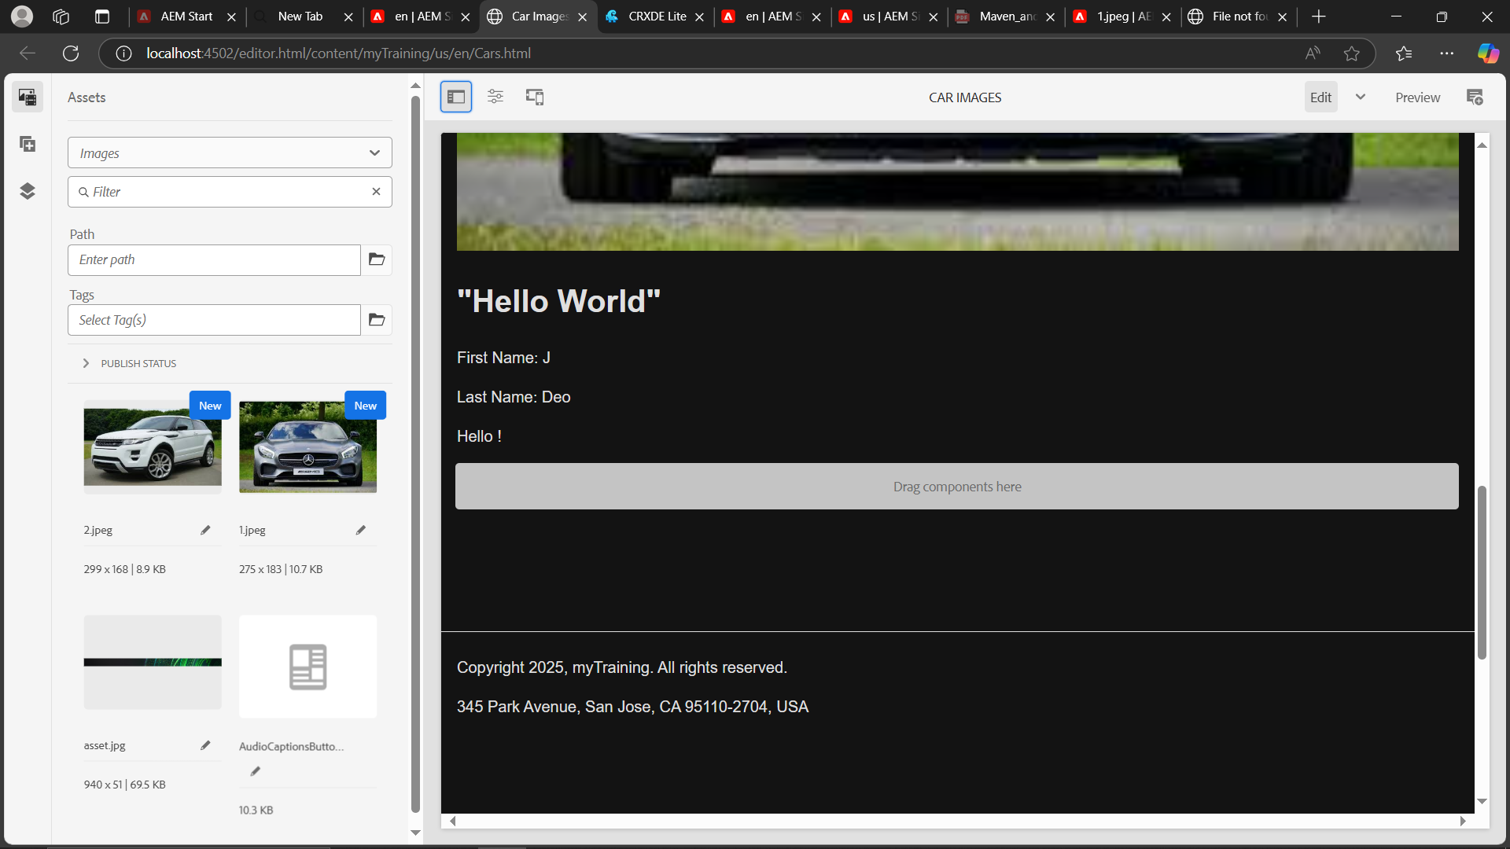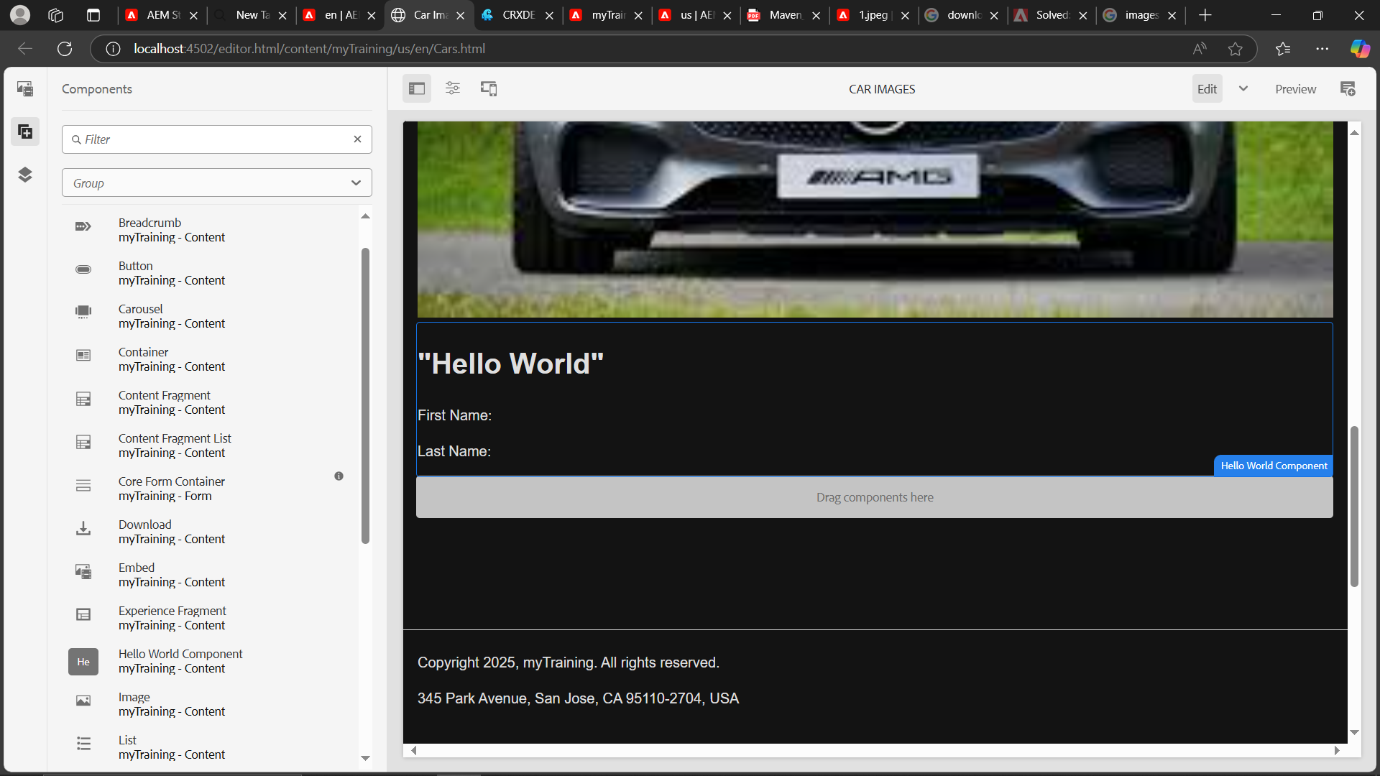

### ****5. Use**** @ValueMapValue ****in Sling Model****

**Java Model:**

java

CopyEdit

package com.myTraining.core.models;

import javax.inject.Inject;

import org.apache.sling.api.resource.Resource;

import org.apache.sling.models.annotations.DefaultInjectionStrategy;

import org.apache.sling.models.annotations.Model;

import org.apache.sling.models.annotations.injectorspecific.ValueMapValue;

@Model(adaptables = Resource.class, defaultInjectionStrategy = DefaultInjectionStrategy.OPTIONAL)

public class HelloWorldModel {

@ValueMapValue

private String firstName;

@ValueMapValue

private String lastName;

public String getFirstName() {

return firstName;

}

public String getLastName() {

return lastName;

}

}

**Use in HTL:**

html

CopyEdit

<p data-sly-use.model="com.myTraining.core.models.HelloWorldModel">

Hello ${model.firstName} ${model.lastName}!

</p>

### ****6. Create JAR Packages for DAM & HelloWorld Component****

Use **CRX Package Manager**:

#### Package 1: HelloWorld Component

1. Go to http://localhost:4502/crx/packmgr/index.jsp
2. Click **Create Package**
   * Name: myTraining.helloworld
   * Group: myTraining
3. Add filters:
   * /apps/myTraining/components/helloworld
   * /apps/myTraining/core (if model class is there)

#### Package 2: DAM Assets

1. Create another package:
   * Name: myTraining.assets
   * Group: myTraining
2. Filter:
   * /content/dam/myTraining/us/en-us

Then click **Build → Download** the JARs.

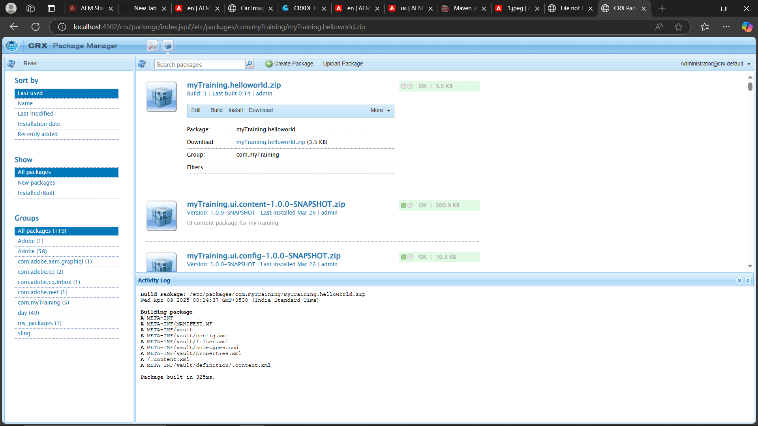

### ****7. Configure Replication Agent & Publish****

**Steps:**

1. Login to **Author (4502)** → http://localhost:4502/etc/replication/agents.author.html
2. Create a new replication agent:
   * Title: Default Publish
   * Transport URI: http://localhost:4503/bin/receive
   * Transport User: admin
   * Transport Password: admin
3. Save and **Test Connection**
4. Go to your page in **Sites**
   * Select → Click **Publish → Activate**

Done! The page and assets will be replicated to Publish (4503).

